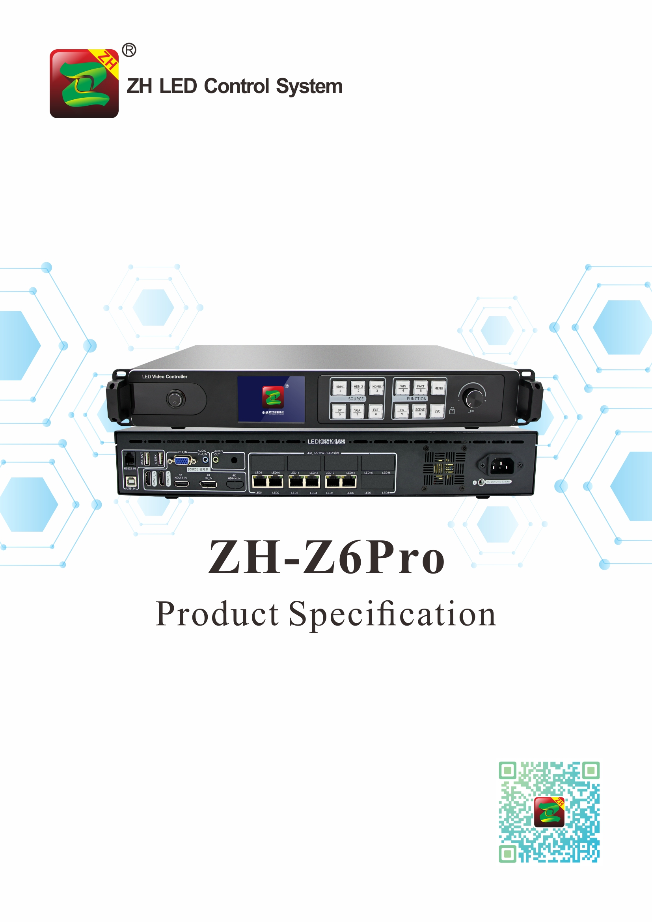

Product Specification
ZH-Z6Pro
I. Product Introduction:
ZH-Z6Pro two-in-one multi-window video player is a product produced by ZH to meet the convenience of large LED screen installation. It supports HDMI, DP and other high-definition signals four-window arbitrary roaming input; support max pixel 4096*2160@60Hz, 6 PCS Gigabit Ethernet port output, single device supports pixels: Max width 8192,or Max Height 4096. Adopt new communication architecture, high refresh, high brightness, new grayscale scanning engine, nanosecond synchronization, and communication can be maintained smoothly under bad communication conditions, allowing users to experience a more colorful and better LED world!

II. Functional Features：
- Input interfaces, 1pcs HDMI 2.0, 2pcs HDMI 1.4, 1pcs DP, 1pcs VGA;
2. Input resolution: Max pixel is 4096*2160@60Hz,supports arbitrary setting of resolution;
3. Single card Max loading: 3.9 million points, Max Width 16384, Max Height: 4320;
4. Support arbitrary switching of video sources, splicing and zooming input images according to the resolution of the display screen;
5. Support four windows free roaming;
6. Support dual 4K@60HZ input;
7. Support multi-machine 4K splicing and cascading;
8. Support audio input and output;
9. Support brightness and color temperature adjustment;
10. 6 PCS Gigabit Ethernet port output, support arbitrary splicing up and down, left and right;
11. Support hot backup: two network ports in the same group for hot backup and multi-card hot backup;
12. Support two debugging methods of device panel and PC;
13. Support low brightness and high gray;
14. Support ZH full series of receiving cards, multi-function cards, and fiber optic transceivers;

III. Topology Diagram:
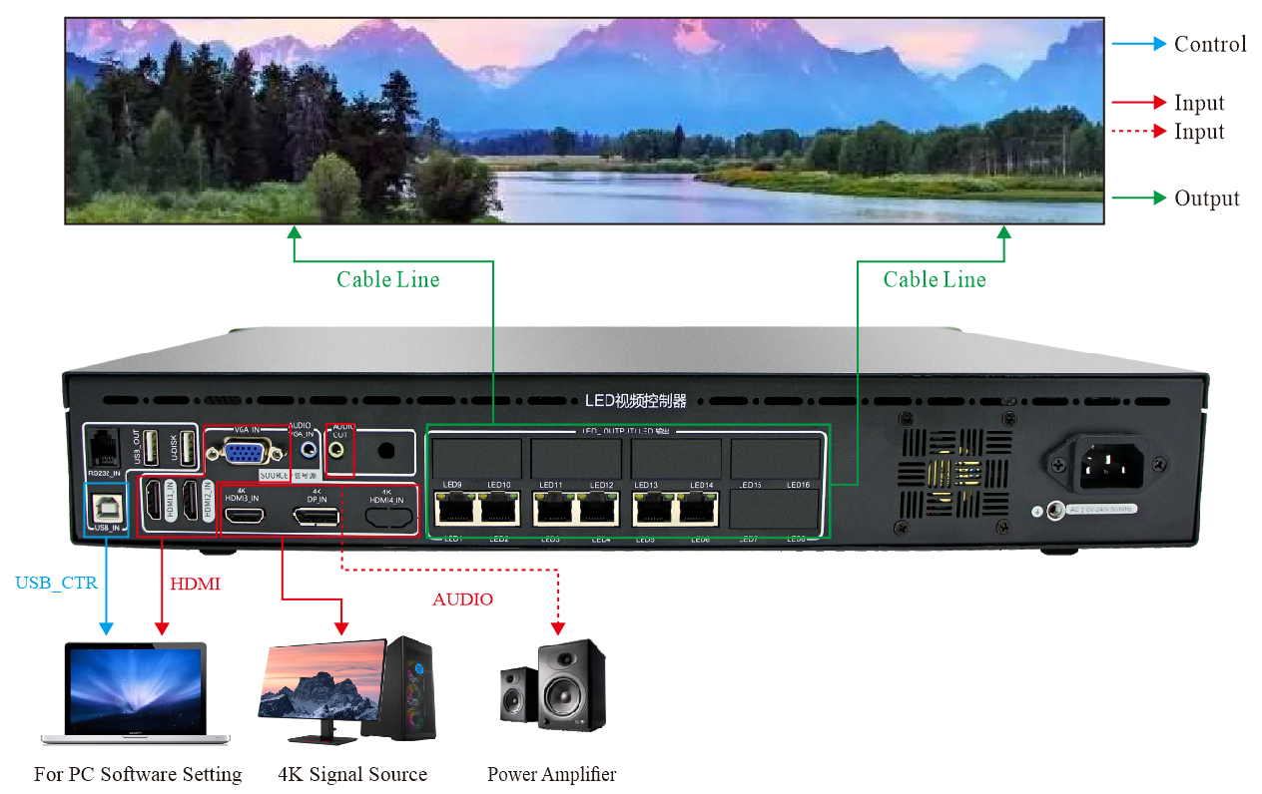

IV. Hardware Introduction:

The Front Panel
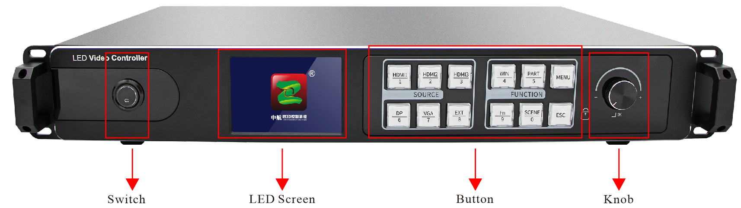
Switch | The power switch
LCD | Show the device status and operation interface
Knob | Pressing:To enter or confirm;  Rotation: To move the cursor or modify parameters

Button Part Manual
SOURCE |  | FUNCTION
HDMI/1 | HDMI 1/number 1 | WIN/4 | Multi-window settings/number 4
HDMI/2 | HDMI 2/number 2 | PART/5 | Partial and Full switch/number 5
HDMI/3 | HDMI 3/number 3 | MENU | Enter the menu advanced setting mode
DP/6 | DP/number 6 | FN/9 | Compound key/number 9
VGA/7 | VGA/number 7 | SCENE/0 | Scene shortcut key/number 0
EXT/8 | EXT/number 8 | ESC | Back

The Back Panel
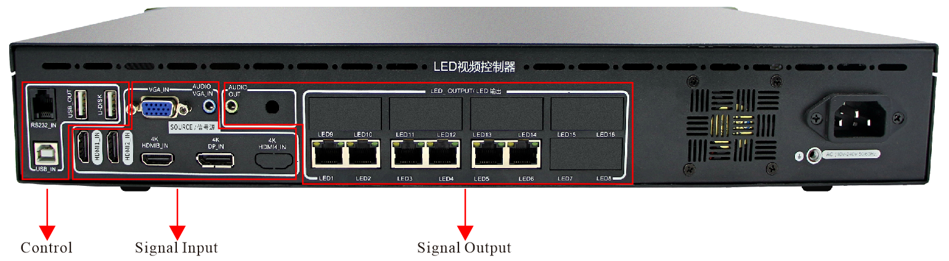

CONFIG |  | Single Input |  | Single Output
USB_IN | System setting port | HDMI_IN*3 | HDMI input | LED*6 | LAN output 1--6
USB_OUT | Device cascading interface port | 4K DP_IN | DP input | AUDIO_OUT | Audio output
U-DISK | Reserved port | VGA_IN | VGA input
RS232_IN | Central control serial port | AUDIO VGA_IN | VGA audio input

Input:

Port | Quantity | Resolution
HDMI 1.4 | 2 | EIA/CEA-861 standard
HDMI 2.0 | 1 | EIA/CEA-861 standard, compliant with HDMI-2.0 standard, support HDCP2.2
VGA | 1 | Support 1920*1200/60Hz and so on, match VESA standard resolution
DP | 1 | Match DP-1.2 standard, support HDCP1.3
AUDIO | 1 | 3.5mm standard audio input port
USB | 1 | Standard USB2.0port

Output:
Port | Quantity | Resolution
LED | 6 | Standard Gigabit Ethernet port, support ZH V5 all types of receiving cards, support arbitrary splicing up and down or left and right
AUDIO | 1 | 3.5mm standard audio output port

Chassis parameters:
Power Input | AC 100~240V，50/60Hz,not more than 1A
Temperature | -20~45℃
Size | 482*327.73*72(mm,L*W*H)
Weight | ≈4.3KG

VI. Hardware Diagram:
Unit: mm
